**Case Study: Shopping Cart System**

**Stakeholders:**

* User
* Admin

**User Flow:**

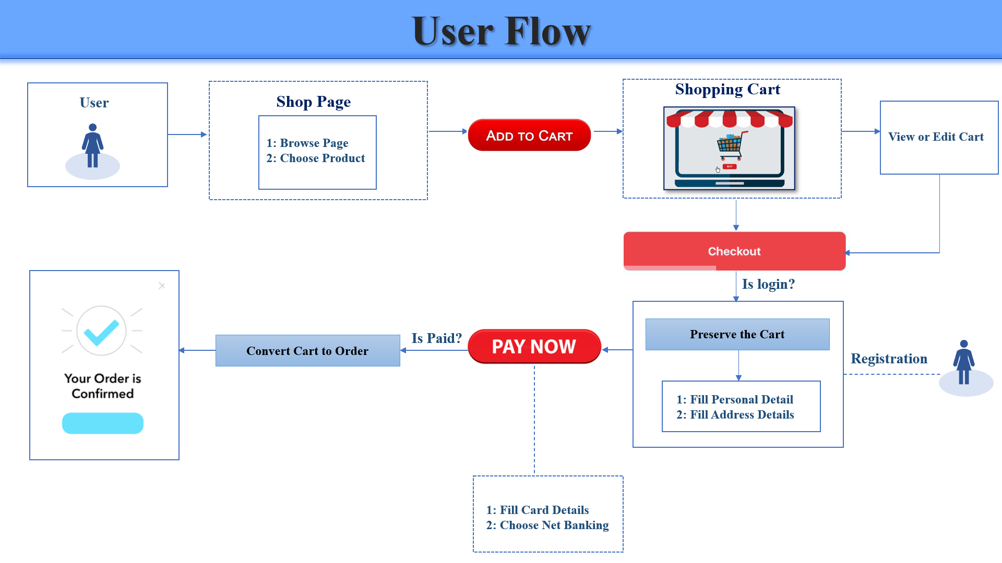

**Admin Flow:**

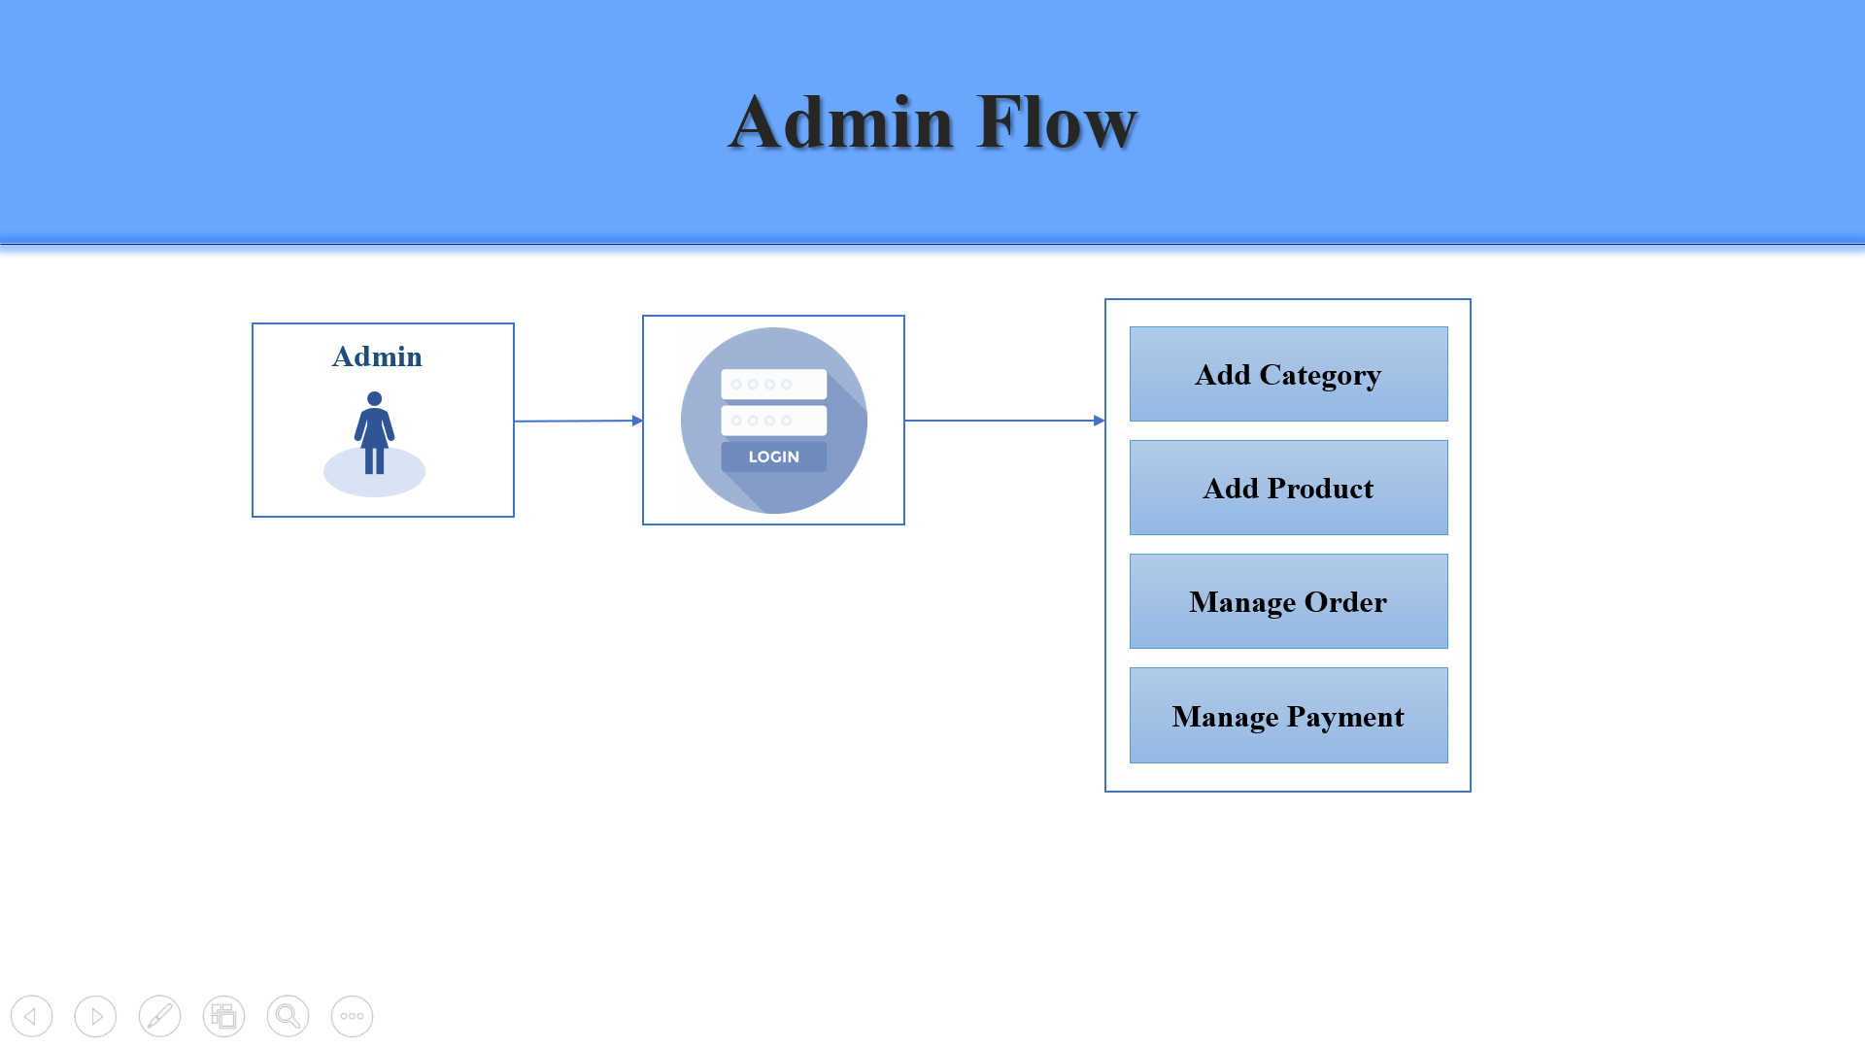

**Functionalities:**

* User Registration
* CRUD Operations
* User can add products to their cart
* Admin can add products to the product list
* Admin can edit the product details
* Admin can delete the products from the list
* Spring Security
  + User can login to the web application
  + According to the role, access will be granted
  + User can logout
* Confirmation
* After product is added to the cart, User can checkout
* Confirming User details
* If user submit the checkout, Order Successful page will appear
* If user cancel the web flow, Order Failure page will appear

**Database:**

* User
  + user id
  + user name
  + user password
  + user email
  + user address
* Admin
  + id
  + name
  + password
* Product Category
  + category id
  + category name
  + category type
* Product
  + product id
  + product name
  + product price
  + product description
  + product status
* Order
  + order id
  + order amount
  + order status